Title of Your Contribution
First Author¹, Second Author², and Third Author^{1,2*}
1)First University, City, Country
2)Second University, City, Country
*) E-mail third.author@univ.org

In this paper we report that we have measured everything measurable [1] and observed everything observable [2]. However we could describe everything within 1-2 pages using 12 pts Times New Roman and 1-2 figures.
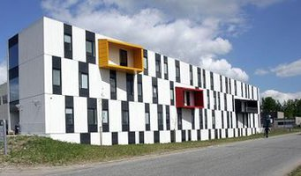
Figure 1. Conference venue at Aalborg University
References.
[1] M. R. Jones, K. D. Osberg, R. J. Macfarlane, M. R. Langille, C. A. Mirkin, Chem. Reviews 111, 3736–3827 (2011).
[2] A. P. Alivisatos, K. P. Johnsson , X. G. Peng, T. E. Wilson, C. J. Loweth, M. P. Bruchez, P. G. Schultz, Nature 382, 609-611 (1996).

